Group: 6

Member:

|  |  |
| --- | --- |
| Student1032633 | NGUYEN HUU DAM |
| Student1040277 | TO NGUYEN THIEN CHI |
| Student1048374 | DINH HOANG QUAN |

**I. Architecture & Design of the Project**

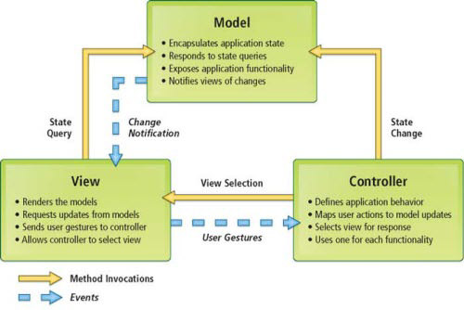

***1. Presentation Tier:***

Is the tier in which the users interact with application . Presentation Tier contents Model, View, Controller used to receive a request and response to User.

Technology: ASP.NET MVC5, HTML, CSS, JavaScript, Ajax, JQUERY, Bootstrap

***2. Business Logic Tier:***

Is mainly working as the bridge between Data Tier and Presentation Tier. All the Data passes through the Business Tier before passing to the Presentation Tier.

Technology: OOP, ASP.NET

***3. Data Access Tier:***

Is basically the server which stores all the application’s data .Data tier contents Database Tables, Database Views and other means of storing Application Data .

Technology: SQL Server, LINQ, ADO.NET

**II. Algorithms - Data Flowchart:**

**Symbol generates:**

Process Decision

Start/End Program Flow

Data

1. **Main data flow for candidate**.

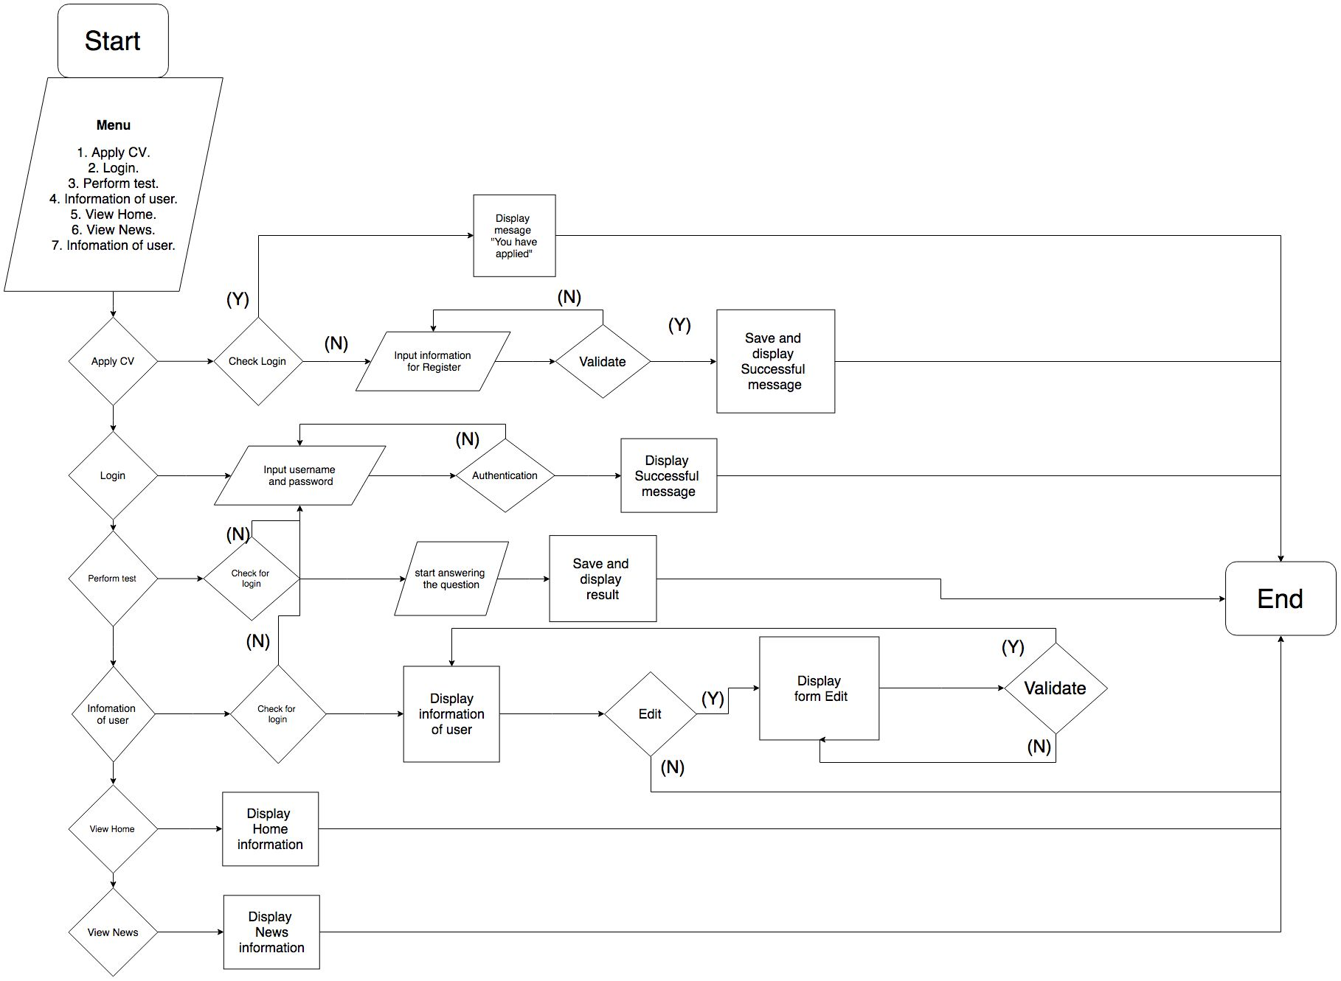

1. **Main data flow for manager.**

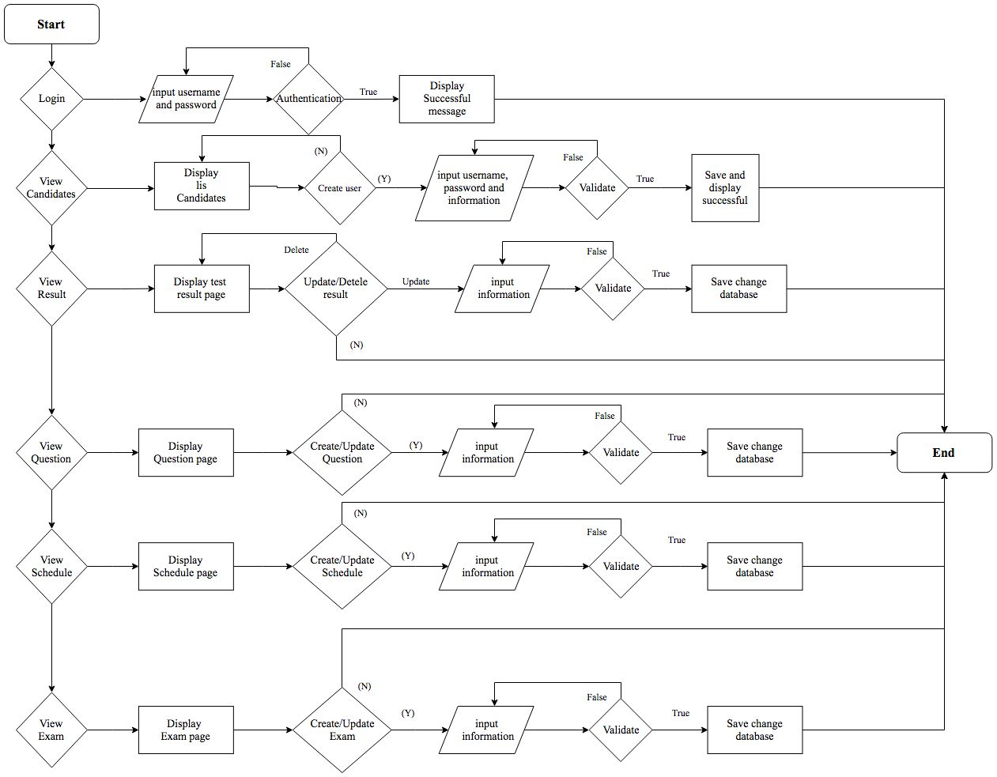

1. **Add new record.**



1. **Edit record.**



1. **Search information.**



1. **Delete record.**



**III. Data Flow Diagram:**

1. **Level 0 Data Flow Diagram**

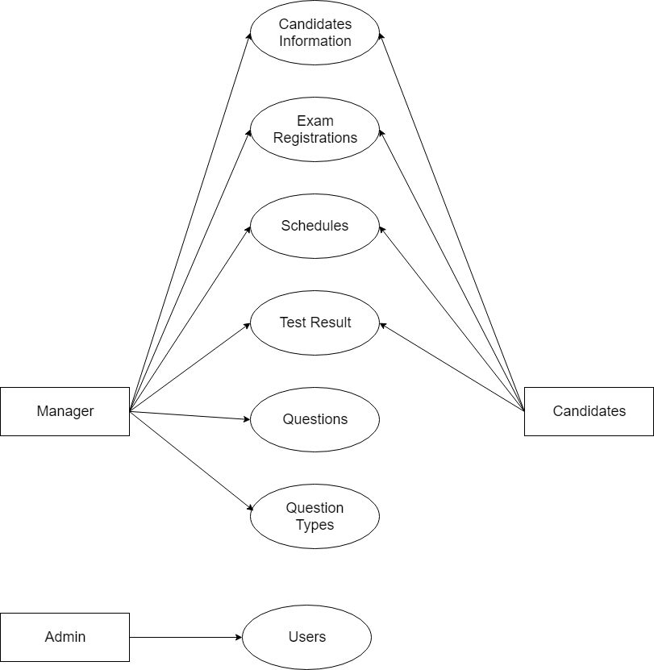

1. **Level 1 Data Flow Diagram**
   1. **Administrator Manage Users**

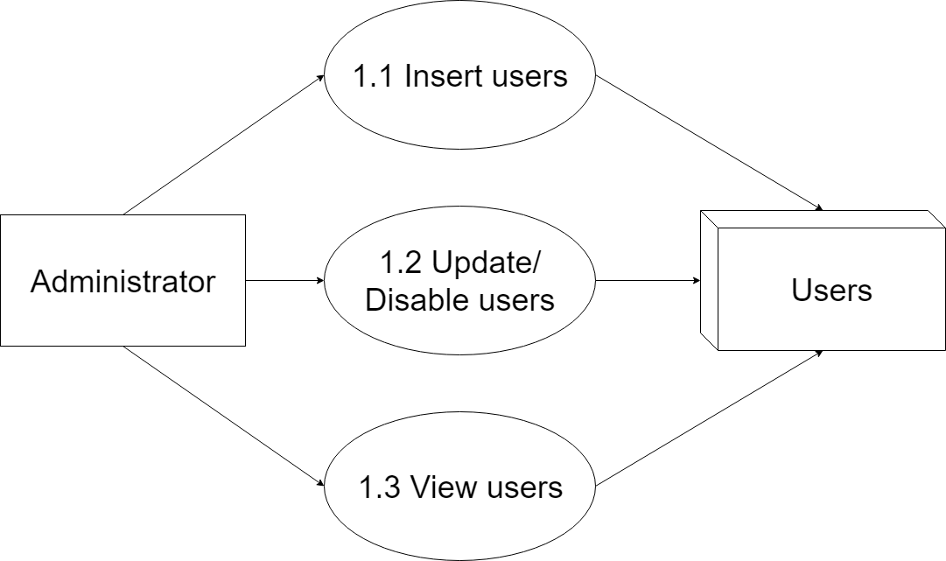

* 1. **Manager Manage Candidates Information**

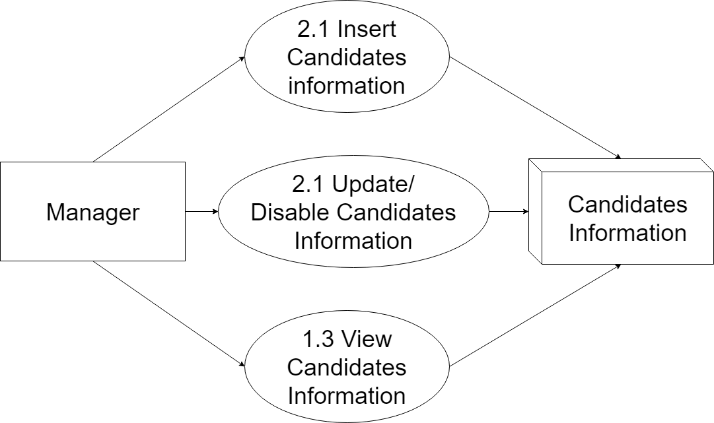

* 1. **Manager Manage Exam Registrations**

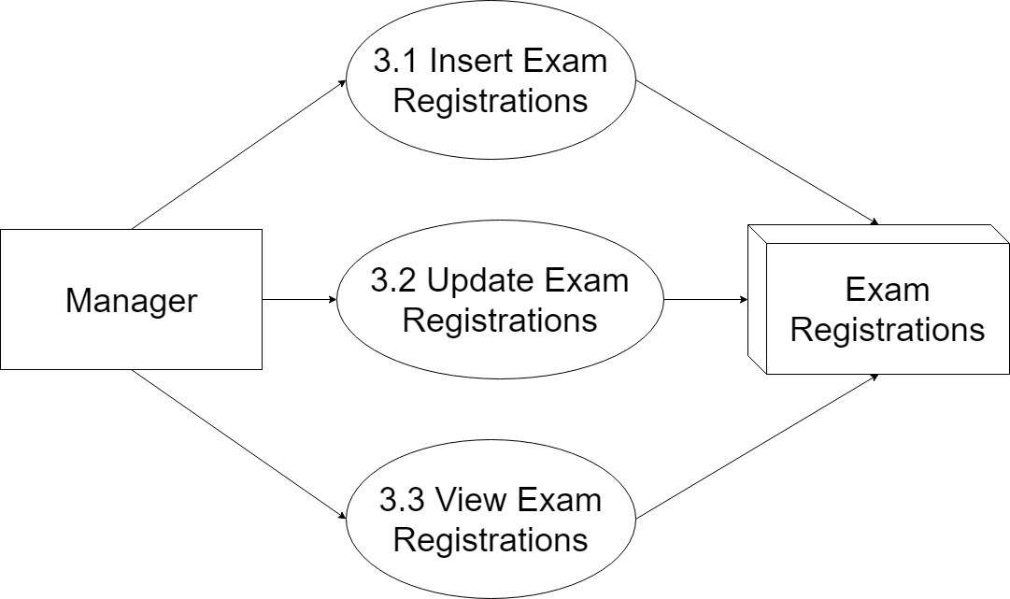

* 1. **Manager Manage Schedule**

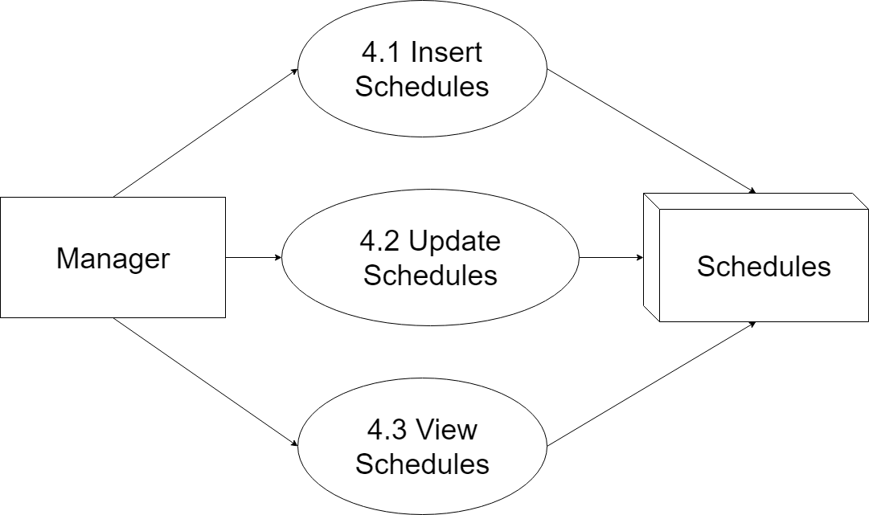

* 1. **Manager Manage Exam Result**

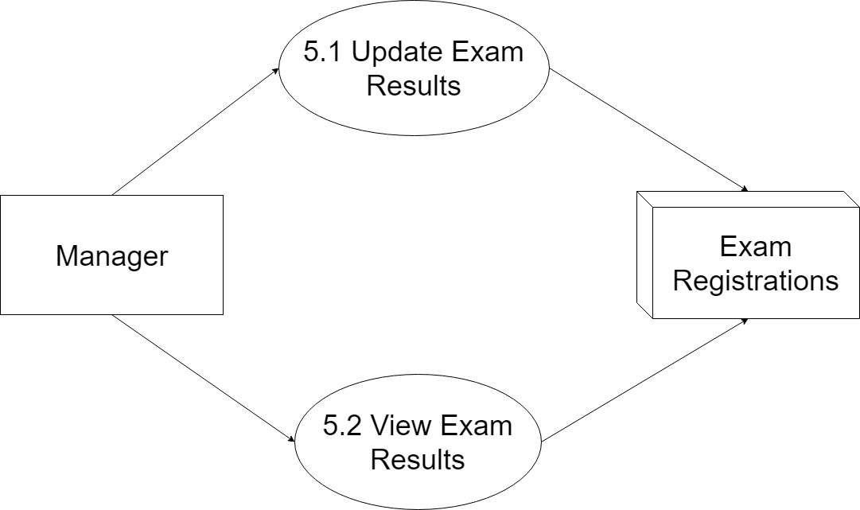

* 1. **Manager Manage Questions**

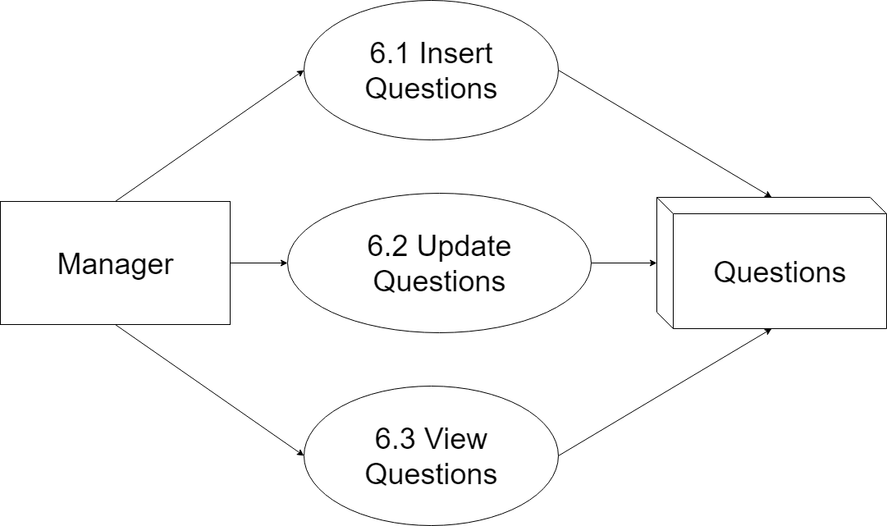

* 1. **Manager Manage Questions Type**

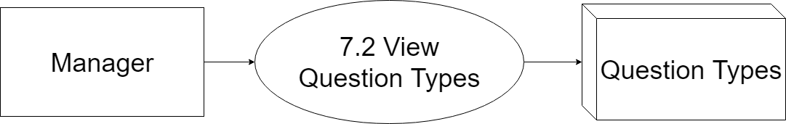

* 1. **Candidate Manage Candidates Information**

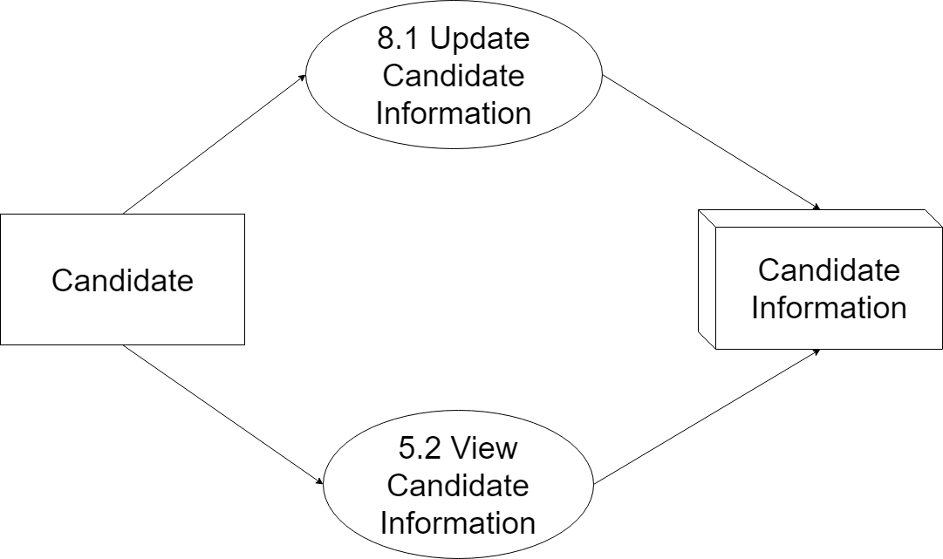

* 1. **Candidate Manage Test Registratrions**

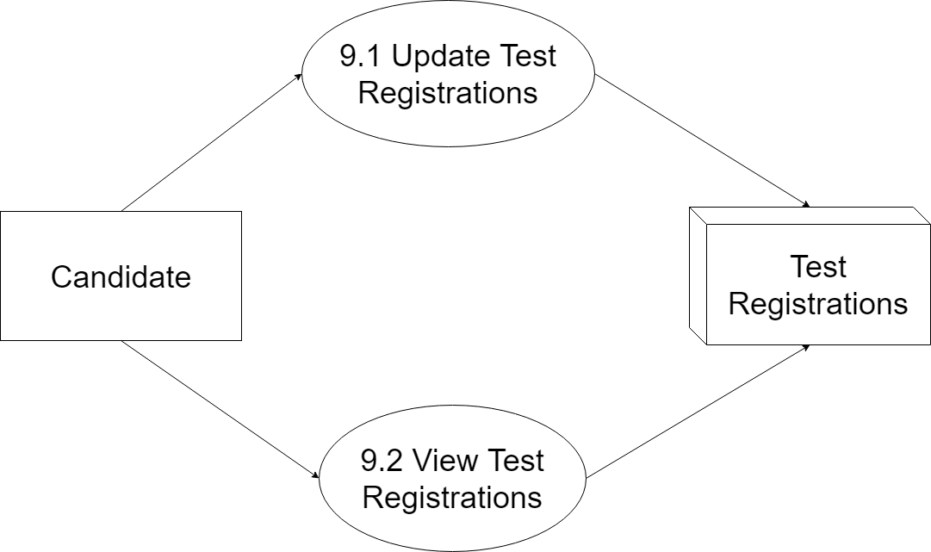

* 1. **Candidate Manage Schedules**

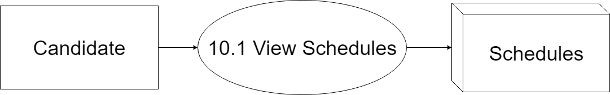

* 1. **Candidate Manage Test Result**

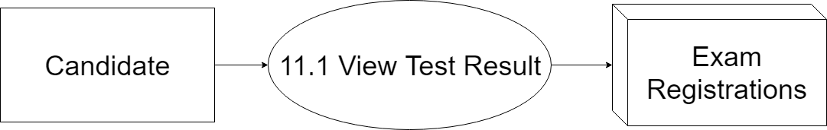

**IV. Use Case Diagram:**

1. **Administrator Use Case**

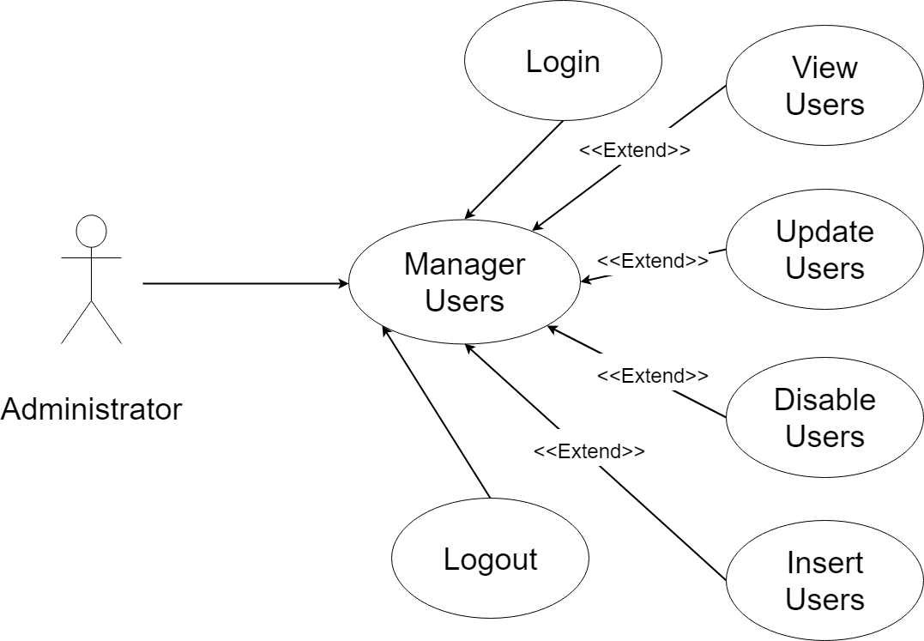

1. **Manager Use Case**

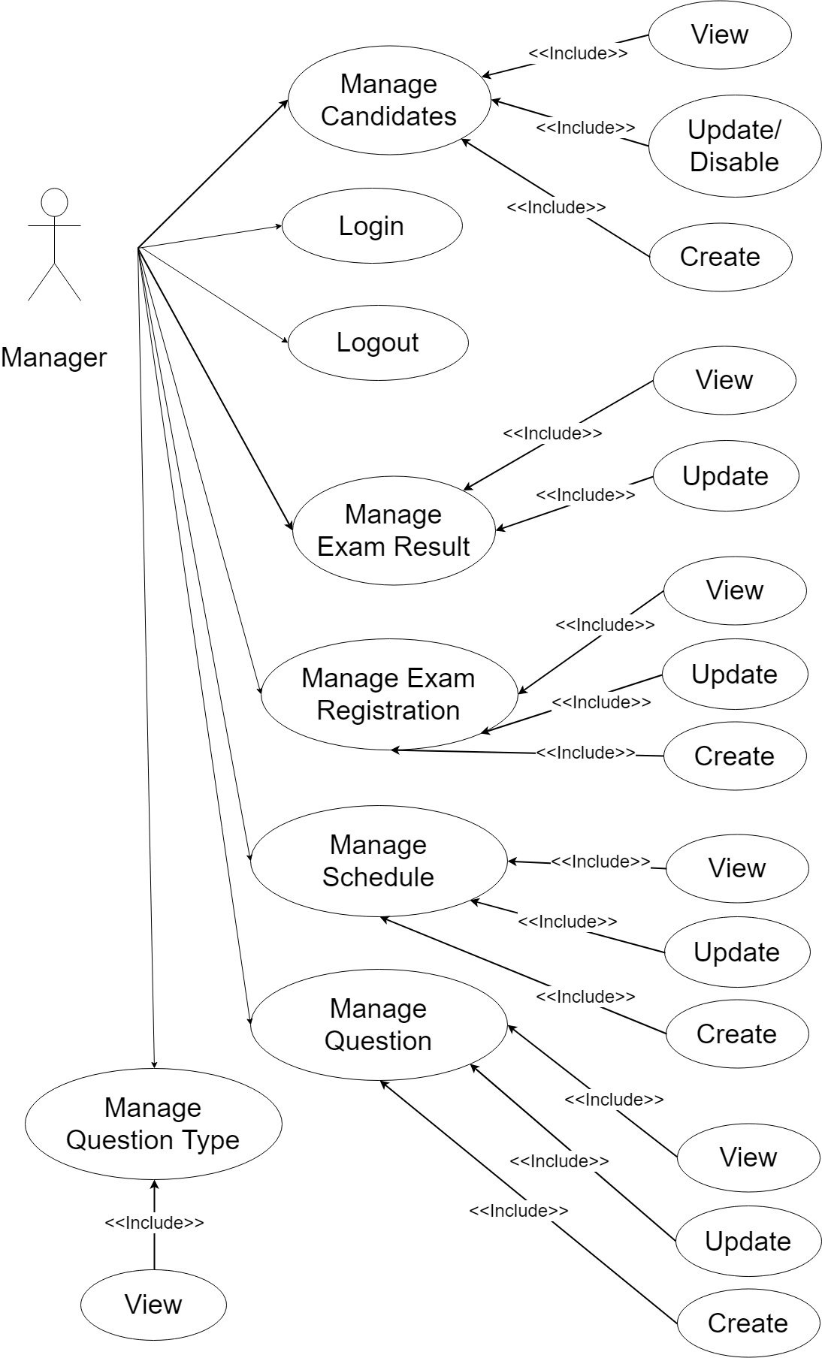

1. **Candidate Use Case**

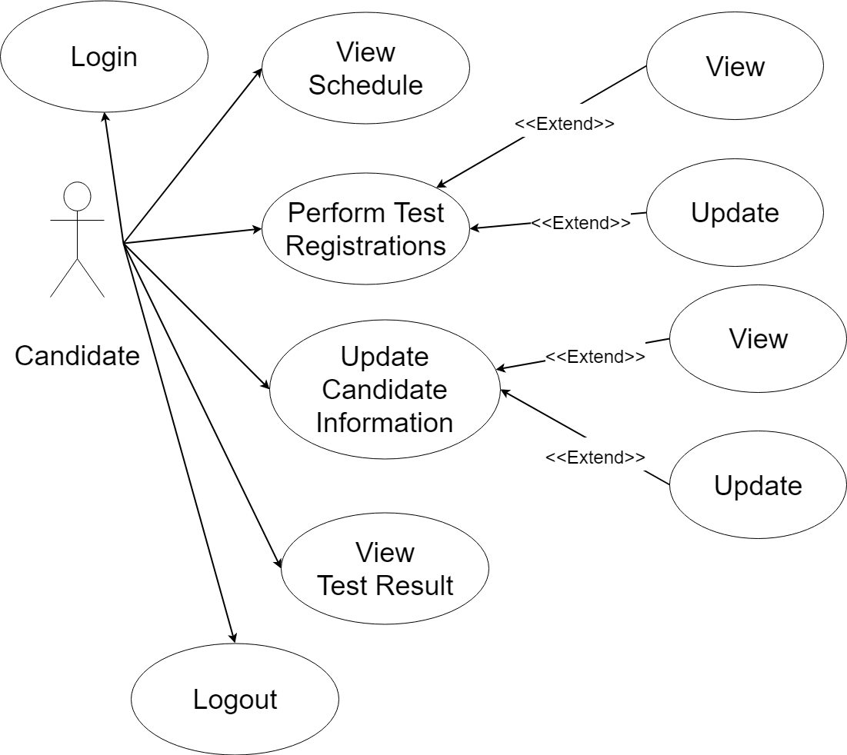

**V. Sequence Diagram:**

1. 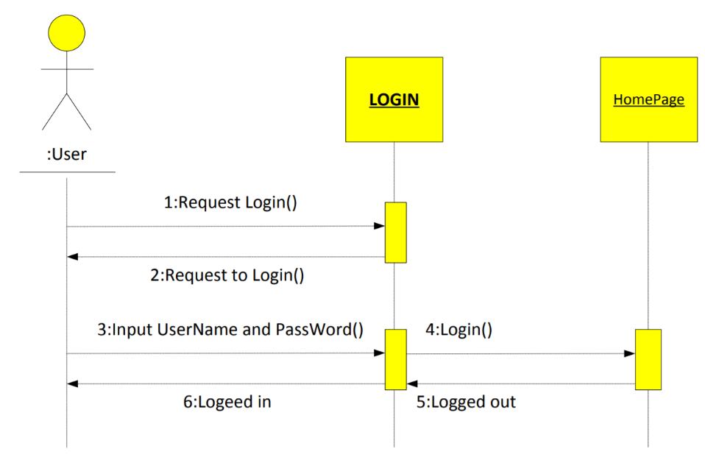**Login:**

**Use Case Description:**

|  |  |  |  |
| --- | --- | --- | --- |
| **Name** | Login | **Code** | UC01 |
| **Description** | Allows users to log into the system | | |
| **Users** | Admin, candidates | **Trigger** |  |
| **Pre-condition** |  | | |
| **Post condition** | Go to the login page except home page | | |

**Activities:**

|  |  |  |  |
| --- | --- | --- | --- |
| **Actor** | | **System** | |
| **Main Flow: Load Home admin clear page is successful** | | | |
| 1 | Click a Manage Account and choose Create a new account. |  |  |
|  |  | 2 | Display textbox to enter information. |
| 3 | Enter complete information for the space. Click the submit Create. |  |  |
|  |  | 4 | Confirmation of accounts on the system. |

**Business Rules:**

|  |  |  |
| --- | --- | --- |
| **Rule No.** | **Rule** | **Description** |
| 1 |  | Display error message box account and password.  Input password in a state of no data |
| 2 |  | If ( username and password are true) login is successfully. |

**System Message:**

|  |  |
| --- | --- |
| MS01 | “Wrong Username”  Notice in the page display.  “Wrong Password”  Notice in the page display. |

1. 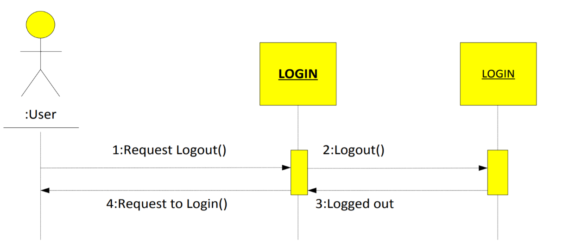**Logout:**

**Use Case Description:**

|  |  |  |  |
| --- | --- | --- | --- |
| **Name** | Logout | **Code** | UC02 |
| **Description** | Allow user log off the system | | |
| **Users** | Admin, candidates | **Trigger** | When user click the logout button on the page. |
| **Pre-condition** | User must login into the system. | | |
| **Post condition** | Return to login | | |

**Activities:**

|  |  |  |  |
| --- | --- | --- | --- |
| **Actor** | | **System** | |
| **Main Flow: Login successfully** | | | |
| 1 | User click logout. |  |  |
|  |  | 2 | Return login. |

**Business Rules:**

|  |  |  |
| --- | --- | --- |
| **Rule No.** | **Rule** | **Description** |
| 1 |  | Click logout when they return to login. |

**System Message:**

|  |  |
| --- | --- |
| MS01 | Show successfully singed informed |

1. **Register user candidates**

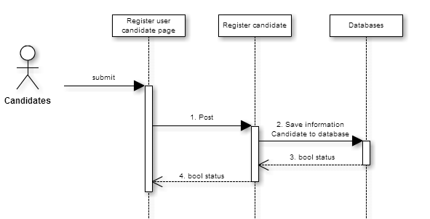

**Use Case Description:**

|  |  |  |  |
| --- | --- | --- | --- |
| **Name** | Register user candidates | **Code** | UC10 |
| **Description** | Allows candidates to register an account | | |
| **Actor** | Candidates | **Trigger** | Click register on schedules page. |
| **Pre-condition** |  | | |
| **Post condition** |  | | |

**Activities:**

|  |  |  |  |  |
| --- | --- | --- | --- | --- |
| **Actor** | | **System** | | |
| **Main Flow: View notify for leaves successfully** | | | | |
| 1 | Click register on schedules page. | |  |  |
|  |  | | 2 | Redirect new candidates page |
| 3 | Enter information and click save. | |  |  |
|  |  | | 4 | Save candidate information and redirect schedules page |

1. **Manager register user candidates**

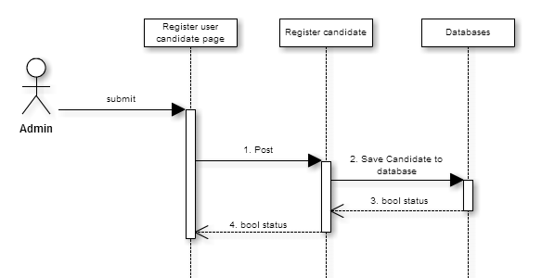

**Use Case Description:**

|  |  |  |  |
| --- | --- | --- | --- |
| **Name** | Manage register user candidates | **Code** | UC11 |
| **Description** | Allow admin to manage register user candidates | | |
| **Actor** | Admin | **Trigger** | Click manage candidates on admin page. |
| **Pre-condition** | You must login system with admin rights | | |
| **Post condition** |  | | |

**Activities:**

|  |  |  |  |
| --- | --- | --- | --- |
| **Actor** | | **System** | |
| **Main Flow: View notify for leaves successfully** | | | |
| 1 | Click manage register on menu |  |  |
|  |  | 2 | Displays a list of registers on page |
| 3 | Click register |  |  |
|  |  | 4 | Redirect new candidate page |
| 5 | Enter information and click save. |  |  |
|  |  | 6 | Save candidate information and redirect management register |

1. **Manage questions**

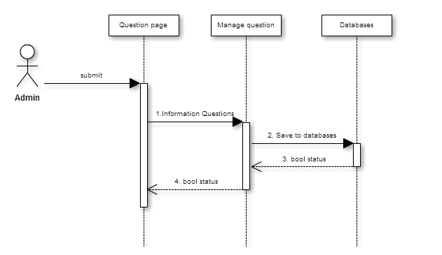

**Use Case Description**

|  |  |  |  |
| --- | --- | --- | --- |
| **Name** | Manage Question | **Code** | UC06 |
| **Description** | Allow admin to manage questions | | |
| **Actor** | Admin | **Trigger** | Click manage question on admin page. |
| **Pre-condition** | You must login system with admin rights | | |
| **Post condition** |  | | |

**Activities:**

|  |  |  |  |
| --- | --- | --- | --- |
| **Actor** | | **System** | |
| **Main Flow: View notify for leaves successfully** | | | |
| 1 | Click manage questions on menu |  |  |
|  |  | 2 | Displays a list of questions on page |
| 3 | Click new question |  |  |
|  |  | 4 | Redirect new question page |
| 5 | Enter information and click save. |  |  |
|  |  | 6 | Save the question and redirect management questions |
| 5 | Click update button. |  |  |
|  |  | 6 | Redirect update question page |
| 7 | Enter information and click save. |  |  |
|  |  | 8 | Save the question and redirect management questions |

1. **Manage schedule**

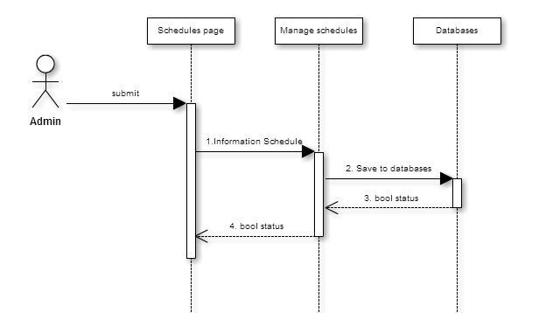

**Use Case Description:**

|  |  |  |  |
| --- | --- | --- | --- |
| **Name** | Manage schedule | **Code** | UC07 |
| **Description** | Allow admin to manage schedule | | |
| **Actor** | Admin | **Trigger** | Click manage schedule on admin page. |
| **Pre-condition** | You must login system with admin rights | | |
| **Post condition** |  | | |

**Activities:**

|  |  |  |  |
| --- | --- | --- | --- |
| **Actor** | | **System** | |
| **Main Flow: View notify for leaves successfully** | | | |
| 1 | Click manage schedules on menu |  |  |
|  |  | 2 | Displays a list of schedule on page |
| 3 | Click new schedules |  |  |
|  |  | 4 | Redirect new schedule page |
| 5 | Enter information and click save. |  |  |
|  |  | 6 | Save the schedule and redirect management schedules |
| 5 | Click update button. |  |  |
|  |  | 6 | Redirect update schedule page |
| 7 | Enter information and click save. |  |  |
|  |  | 8 | Save the schedule and redirect management schedules |

1. **Manage exam**

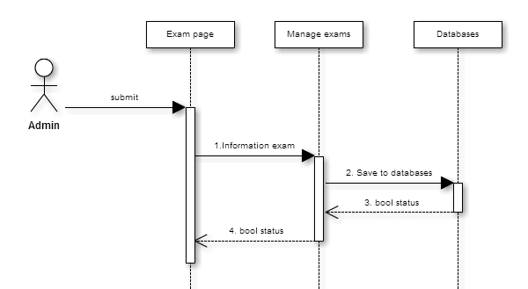

**Use Case Description**

|  |  |  |  |
| --- | --- | --- | --- |
| **Name** | Manage Exam | **Code** | UC08 |
| **Description** | Allow admin to manage exams | | |
| **Actor** | Admin | **Trigger** | Click manage exams on admin page. |
| **Pre-condition** | You must login system with admin rights | | |
| **Post condition** |  | | |

**Activities:**

|  |  |  |  |
| --- | --- | --- | --- |
| **Actor** | | **System** | |
| **Main Flow: View notify for leaves successfully** | | | |
| 1 | Click manage exams on menu |  |  |
|  |  | 2 | Displays a list of exams on page |
| 3 | Click new exam |  |  |
|  |  | 4 | Redirect new exam page |
| 5 | Enter information and click save. |  |  |
|  |  | 6 | Save the exam and redirect management exams |
| 5 | Click update button. |  |  |
|  |  | 6 | Redirect update exam page |
| 7 | Enter information and click save. |  |  |
|  |  | 8 | Save the exam and redirect management exams |

1. **Manage test results**

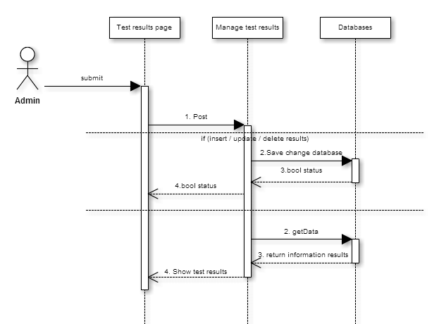

**Use Case Description**

|  |  |  |  |
| --- | --- | --- | --- |
| **Name** | Manage Test Results | **Code** | UC09 |
| **Description** | Allow admin to manage Test Results | | |
| **Actor** | Admin | **Trigger** | Click manage result on admin page. |
| **Pre-condition** | You must login system with admin rights | | |
| **Post condition** |  | | |

**Activities:**

|  |  |  |  |
| --- | --- | --- | --- |
| **Actor** | | **System** | |
| **Main Flow: View notify for leaves successfully** | | | |
| 1 | Click manage result on menu |  |  |
|  |  | 2 | Displays a list of result on page |
| 3 | Click new result |  |  |
|  |  | 4 | Redirect new result page |
| 5 | Enter information and click save. |  |  |
|  |  | 6 | Save the result and redirect management result |
| 5 | Click update button. |  |  |
|  |  | 6 | Redirect result question page |
| 7 | Enter information and click save. |  |  |
|  |  | 8 | Save the result and redirect management result |

1. **View the schedule**

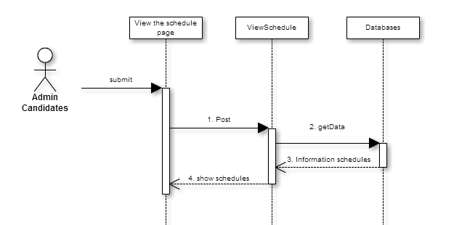

**Use Case Description**

|  |  |  |  |
| --- | --- | --- | --- |
| **Name** | View the schedules | **Code** | UC12 |
| **Description** | Allow user view the schedules | | |
| **Actor** | Admin, Candidate | **Trigger** | Click schedules on menu |
| **Pre-condition** |  | | |
| **Post condition** |  | | |

**Activities:**

|  |  |  |  |
| --- | --- | --- | --- |
| **Actor** | | **System** | |
| **Main Flow: View notify for leaves successfully** | | | |
| 1 | Click schedules on menu |  |  |
|  |  | 2 | Displays a list of schedules on page |

1. **View results**

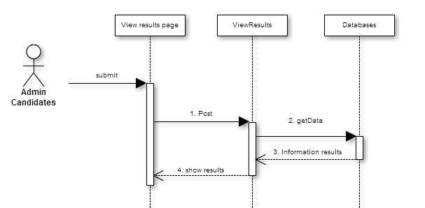

**Use Case Description**

|  |  |  |  |
| --- | --- | --- | --- |
| **Name** | View results | **Code** | UC13 |
| **Description** | Allow candidates see test results | | |
| **Actor** | Candidates | **Trigger** | Click View results on candidates page. |
| **Pre-condition** | You must login system with candidate rights | | |
| **Post condition** |  | | |

**Activities:**

|  |  |  |  |
| --- | --- | --- | --- |
| **Actor** | | **System** | |
| **Main Flow: View notify for leaves successfully** | | | |
| 1 | Click show results on menu |  |  |
|  |  | 2 | Displays a list of results on page |

1. **Perform test**

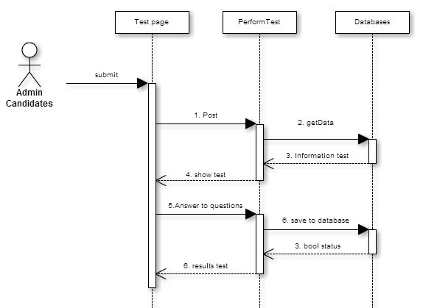

**Use Case Description**

|  |  |  |  |
| --- | --- | --- | --- |
| **Name** | Perform test | **Code** | UC14 |
| **Description** | Allow candidate exam | | |
| **Actor** | Candidates | **Trigger** | Click Perform test on this page. |
| **Pre-condition** | User must login on the system. | | |
| **Post condition** |  | | |

**Activities:**

|  |  |  |  |
| --- | --- | --- | --- |
| **Actor** | | **System** | |
| **Main Flow: View notify for leaves successfully** | | | |
| 1 | Click Perform test on menu. |  |  |
|  |  | 2 | Redirected General Knowledge test page |
| 3 | Enter information and click next. |  |  |
|  |  | 4 | Redirected Mathematics test page |
| 5 | Enter information and click next. |  |  |
|  |  | 6 | Redirected Computer Technology test page |
| 7 | Enter information and click finished |  |  |
|  |  | 8 | Take the test information and Redirected result page |
| 9 | Show results |  |  |

**VI. Entity–Relationship Design:**

**Quan**

**VII. Task sheet review 2**